DISHES AND THEIR ALLERGEN CONTENT – SMOKE BBQ

DISHES  Veggie | 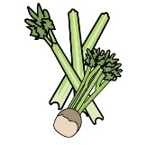 |  | 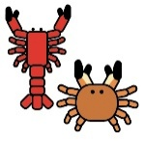 |  |  |  |  |  | 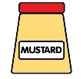 |  |  | 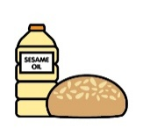 |  | 
 | Celery | Cereals containing gluten | Crustaceans | Eggs | Fish | Lupin | Milk | Mollusc | Mustard | Nuts | Peanuts | Sesame seeds | Soya | Sulphur Dioxide
Tuna Salad [example] | ✓ |  |  | ✓ | ✓ |  | ✓ |  | ✓
Corn Ribs |  | x |  |  |  |  | x
Pulled Jackfruit |  | X |  |  |  |  | X |  | X

Review date: | 8.1.26 | Reviewed by: | J Quirk |  | You can find this template, including more information at www.food.gov.uk/allergy

