DISHES AND THEIR ALLERGEN CONTENT – Firehouse Glasgow

DISHES  Sauces | 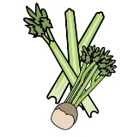 |  | 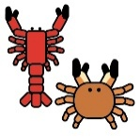 |  |  |  |  |  | 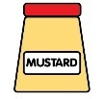 |  |  | 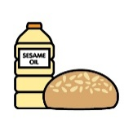 |  | 
 | Celery | Cereals containing gluten | Crustaceans | Eggs | Fish | Lupin | Milk | Mollusc | Mustard | Nuts | Peanuts | Sesame seeds | Soya | Sulphur Dioxide
Tuna Salad [example] | ✓ |  |  | ✓ | ✓ |  | ✓ |  | ✓
Garlic Mayo |  |  |  | X |  |  |  |  |  |  |  |  |  | X
Cowboy Butter |  |  |  |  | x |  | x |  | x
House BBQ |  |  |  |  |  |  |  |  | X
Citrus |  |  |  |  |  |  |  |  | X
Buffalo
Ranch |  |  |  | X |  |  | X |  |  |  |  |  |  | X
Habanero Honey
Louisianna Chipotle |  |  |  | X
Korean BBQ |  | X |  |  |  |  |  |  |  |  |  |  | X

Review date: | 8.1.26 | Reviewed by: | J Quirk |  | You can find this template, including more information at www.food.gov.uk/allergy

